North Fields Afforestation Project

Project Description Document

Completed by Tomorrow’s Climate Solutions: October 14th, 2016.

Introduction

Project Title:
North Fields Afforestation Project

Purpose & Objective(s):
The purpose of this project is to sequester atmospheric carbon dioxide (CO₂) through the afforestation of previously agricultural land presently managed as meadow. The Carbon Management Fund, an Oberlin College student run group, developed this project to serve as an active experiment, comparing a section of the project that has been planted with saplings against project areas that are being encouraged to self-recruit and naturally succeed to forest. Atmospheric levels of CO₂ reduced through this project will be estimated using growth models for trees, shrubs and other carbon sinks and applied to offset the carbon footprint of Oberlin College. Additionally, the project seeks to benefit the surrounding community through co-benefits of project implementation by increasing forested area with benefits including: water & air filtration, local & migratory wildlife & pollinator habitat, heat reduction, wind break and storm barriers. Furthermore, the project adds educational co-benefits for Oberlin College students who can engage and fulfill project research, monitoring and accounting. As one of the first projects of its kind, using the Second Nature Peer Review Network’s protocols and utilizing Peer Review to accomplish verification, this project seeks to pioneer this option for carbon offset project creation and provide an example for future efforts.

Type of GHG Project:
The North Fields Afforestation Project is an Afforestation Project which quantifies emissions based on forest stock monitoring. The project’s GHG impact will be calculated by applying peer-reviewed research to estimate the growth rates of planted and self-recruiting tree species on the project site.

Site Details
Project Location:
The North Fields Afforestation Project is located just beyond the city limits of Oberlin whose population is ~8,500, set in the agricultural landscape of Lorain County Ohio. The land is owned and managed by Oberlin College whose athletic fields are just east of the project site separated by a chain-link fence. Just south of the project site is a solar array that was constructed in the Fall of 2012 that is owned by Oberlin College but managed by the solar energy company and is fenced directly along the solar array’s perimeter. The afforestation project sites include the five areas demarcated in green in the image provided below and is a total of 8.86 acres. Running along the existing tree line of the project site in the image below is Oberlin College’s cross-country course track. Additionally, mulch pathways allow walkers and runners to pass through the areas around the Project Site and solar arrays. The area experiences a low amount of foot-traffic along the defined paths from college and high school cross country teams, joggers, walkers and student researchers who access the area through gates and pedestrian gaps in the eastern fence.
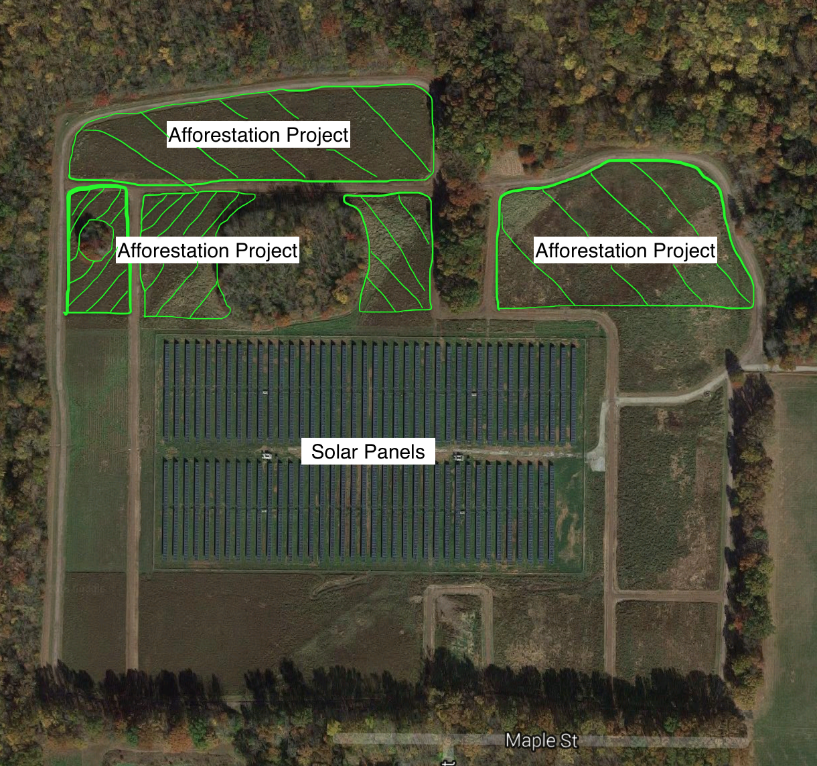
Figure 1: Aerial Image of Project Site (green marks the project site boundaries)
Condition Prior to Project Initiation:
Oberlin College previously managed the project areas as meadow with limited intervention and simulating a burning cycle by mowing twice annually. Prior to this practice of management, the land was leased out to neighboring farmers and farmed in a conventional soy-corn rotation, with intensive fertilizer use. This change in practices occurred in 2012.

GHG Impact
Description of Project Impact on GHG Emissions:
Forest growth involves the removal of CO₂ from the atmosphere by building biomass in trees, roots, shrubs, soil, leaf litter, muff and deadwood. Project areas of new forest will grow, sequestering CO₂ in these measurable and quantifiable carbon sinks. Additionally, the elimination of the practice of simulated burning of these fields, which required mowing the fields twice a year will result in a reduction of GHG emissions from combusted fuel. The emissions reduced through management practice changes add to the project’s GHG Assertion and overall impact.
Project Technologies, Products, and Services:
The North Fields Afforestation Project relies on saplings planted and self-recruited tree species to sequester carbon and promote native species forest growth. Growth models predict trees to store carbon over the project area at an increasing rate ranging from 6.22 to 67.59 tCO₂e stored per year from project year 0 to project year 40 and a total estimated 1209.88 tCO₂e.
The shrub layer is also expected to add substantially to the removal and sequestration of atmospheric GHGs growing to an estimated 20% crown cover level by project year 40 representing a project impact of 185 tCO₂e.
The project excludes the harvest of forest products to eliminate potential sources of leakage and ensure all carbon generated by the project remains on-site. The project will make an estimated 251.06 tCO₂e buffer pool contribution over the course of the project’s lifespan to account for the risk factors identified in the below section “Identification of Risks to GHG Impact of Project”. Ecosystem services will be provided by the project to benefit nearby communities.
GHG Assertion: 1,143.82 tCO₂e
Identification of Risks to GHG Impact of Project:
Project risks are assessed by applying the ACR Tool for Risk Analysis and Buffer Determination V1.0. This tool includes risk factors for afforestation projects including: financial risk, project management risk, social/policy risk, fire risk, disease and pests risk, and the risk of other natural disaster events. Using the guidelines from the ACR Tool for Risk Analysis and Buffer Determination, and applying local area-specific data for occurrence of wildfire, disease and pests, the largest risk factors are Financial, Project Management, and Disease and Pests each posing a 4% risk of project reversal. Social/policy risk, fire, and other natural disasters pose a 2% risk each. Therefore, the total risk factor = 18%, which will be accounted for proportionately through the buffer pool determination later in this document.

Program Eligibility Conditions

Program Name:
Second Nature Carbon Commitment: Peer Review Network

Protocol or Methodology Applied:
Peer Review Network Protocols were applied: General Protocol-v1.3; Afforestation Protocol-v1.3.

Justification of Selected Program, and Protocol or Methodology:
The North Fields Afforestation Project seeks eligibility within Second Nature’s Carbon Commitment, Peer Review Network. The project selected this program, General Protocol-v1.3 and Afforestation Protocol-v1.3 as they reduce non-project related costs, allowing this small-scale project to be realized. Furthermore, the program maximizes educational co-benefits for Oberlin College students who will gain the opportunity to engage and fulfill project research, monitoring and accounting through the selection of this program. Additionally, using the protocols accessible to the Peer Review Network and utilizing Peer Review to accomplish verification, this project seeks to pioneer this option for carbon offset project creation and provide an example for future efforts.
This Project Description Document and the Afforestation Protocol were each developed and approved by the Peer Review Network, using the good practice guidance provided by:
- Climate Action Reserve’s (CAR) Forest Project Protocol Version 3.3 for reforestation projects,
- Verified Carbon Standard (VCS) eligible Clean Development Mechanism (CDM) Methodology Protocol A/R Small-scale Methodology: Afforestation and reforestation project activities implemented on lands other than wetlands (AR-AMS0007),
- 2006 IPCC Guidelines for National Greenhouse Gas Inventories: Volume 4: Agriculture, Forestry and Other Land Use, and
- The American Carbon Registry’s Forest Carbon Project Standard.
Within the Peer Review Higher Education Network, protocols must meet the minimum requirements of marketable offsets as assessed and reviewed by the Technical Advisory Group. Satisfying the requirements of robust protocols will be reviewed by peer institutions with the capacity to assess carbon documentation completeness and accuracy, while performing project verification.
The Peer Review offset network is a tool to enable Colleges and Universities to develop their own carbon offset projects while providing curricular and community benefits through the proximity of projects. Currently in its pilot phase, Peer Review Network-generated carbon offsets are limited to addressing Scope 3 greenhouse gas emissions, up to 30% of total emissions based on the initially submitted GHG inventory to the Second Nature reporting database for the Carbon Commitment.
Legal, Regulatory:
The project is not the result of compliance with any federal state or local law, statute, rule regulation or ordinance. Carbon pools within the project site are governed by the legal contract signed by the Project Owner and Proponent Oberlin College, which covers the 40-year crediting period of the project as well as the 40 years following the crediting period to ensure carbon remains stored in the project site.
Technical:
Oberlin College Grounds Manager, Dennis Greive has adopted the below components which comprise a management plan for the project site. To review the full forest management plan please consult Appendix 2.
- Following the Forest Management Plan;
- Identifying any project reversals/issues that may arise
- Coordinating 5-year visits with the Ohio Division of Forestry to identify the overall health and treatment of invasive species. Mr. John Jolliff is the current State Forester.
- Maintain diversity of native species (>95% based on sum of standing carbon) or management plan to achieve this level of local
- Treat for invasive species by:
- Spot pesticide use — cull exotic/invasive plants (chop them at the base) try to get the plant and the seeds out of the area; and
- Selective culling to discourage Canada thistle and buckthorn.
- Maintain diversity of aged trees within forest (no more than 40% aged less than 20 years excluding significant disturbance) must be met within 25 years
- Encourage habitat for migratory birds through creation of gradual forest edges, i.e. allowing shrubs and small trees to grow at the edge of the forest;
- Zero harvesting/sustainable harvest practices; and
- Increase standing live carbon (calculated by verification) except when a reduction occurs in line with risk reduction practices.

Economic, Sectoral:
(Not Applicable)
Social:
The project owner did not have previously stated goals or plans for the project site’s use or development as a forest. We are aware of no social or cultural elements that might negatively impact the project’s success.
Geographic, Site Specific:
The project site has not experienced commercial harvesting of timber within the last 10 years. The project is within the Peer Reviewed Offset Networks’ designation of local as it qualifies for each of the three definitions offered:
- Accessible by students from the College or University from which Afforestation Project funds originated without requiring greater than 1 day of travel roundtrip to visit the project site;
- Within the same State as the College or University;
- Within 100 miles of the College or University Campus.

Saplings selected for planting include: Sweet Gum (Liquidambar styraciflua), River Birch (Betula nigra), Red Maple (Acer rubrum), and White Oak (Quercus alba), each of which are native to the project site. Self-recruiting saplings will generally be native species, while the management plan details how non-native species will be identified and controlled.

Temporal:
The start date of the project is recorded as ___ which is the date that the project contract was signed. All calculations of project GHG impact shall select the date of this contract’s signature until the present, as the timeframe for measurement of forest growth and carbon accumulation.
While the Peer Review Network remains under development project activity data and documentation will be collected and stored, but no carbon offset credits may be generated from the project until the complete structure for the Peer Review Network is finalized.
Site Preparation:
Site preparation involved auguring holes 1-meter in diameter over a 1.97-acre portion of the project site to plant 100 saplings. This represents a soil disturbance of 0.0077% of the total project area and is therefore below the maximum soil disturbance allowed of 10%. The soil disturbance is thus below the amount allowed by the CDM AR-AMS0007 Protocol without requiring detailed calculation of the impact of this activity.

Roles & Responsibilities
Internal Structure:
The North Fields Afforestation Project was paid for and executed by an arm of the Oberlin College, student led Green EDGE Fund: The Carbon Management Fund. This group receives oversight from the Comptroller and VP of Finance regarding financial decisions, as well as coordinating its activities closely with the Office of Environmental Sustainability. Green EDGE Fund decision are made by its voting student members and approved by either the Comptroller or the VP of Finance.
Participant(s) contact info:
    - Carbon Management Fund, Project Proponent, cmf@oberlin.edu in cooperation with the Office of Environmental Sustainability ____ (Meghan Reisterer?)
    - Dennis Greive, Project Maintainer, dgreive@oberlin.edu
    - Oberlin College (who to designate?), Project Owner, ___
Project Stakeholders:
- Oberlin College, Credit Owner, ___
Relevant regulators & administrators of GHG Program:
- ____, Carbon Commitment: Peer Review Network Coordinator/TAG Group Liaison [Brett? Charles?]
- [Name, Role, Contact Info]
- [Continued…]

Relevant Stakeholder Outcomes & On-going Communication:
In this case, Oberlin College is the sole stakeholder of the project. The afforestation project will benefit Oberlin College by providing carbon-offset credits through the Carbon Commitment’s Peer Review Network towards achieving carbon neutrality as a campus. Oberlin College will also receive the co-benefits from increased forest area as a result of this project. The Project Proponent, the Carbon Management Fund, will receive oversight from Oberlin College’s Office of Environmental Sustainability, and will have email and in person access to the Project Owner ____ and Project Maintainer Dennis Grieve. Communication will follow the project schedule to accomplish accounting, monitoring, verification and other tasks required to keep the project in line with the management plan.
Environmental Impact Assessment:
No Environmental Impact Assessment is required.

Chronological Project Plan
Project Commencement Date: 2016

Project Termination Date: 2056

Frequency of Monitoring and Verification Reporting:
According to the Afforestation Protocol, annual monitoring of the project site will ensure management practices remain in use and identifying disturbance events. After an initial verification, which must occur within 2 years of the commencement date, subsequent verifications will occur at 5 year intervals.

Date | Task | Status
Spring, 2013 | Initial planting, simulated burning practice halted | Complete
Fall, 2013 | Measurement of adjacent forest to track growth | Complete
Spring, 2014 | Signs in place designating afforestation in progress | Complete
Fall, 2015 | 2nd study of adjacent forest confirms initial findings | Complete
 | Project agreement signed and official commencement date | Incomplete
 | Project accounting complete | Incomplete
Annual | Project monitoring, data input, and management system updating occur | On-going
2017; every 5th year thereafter | Initial Project Verification and subsequent verifications at 5-year intervals | On-going

Establishing Project Boundaries
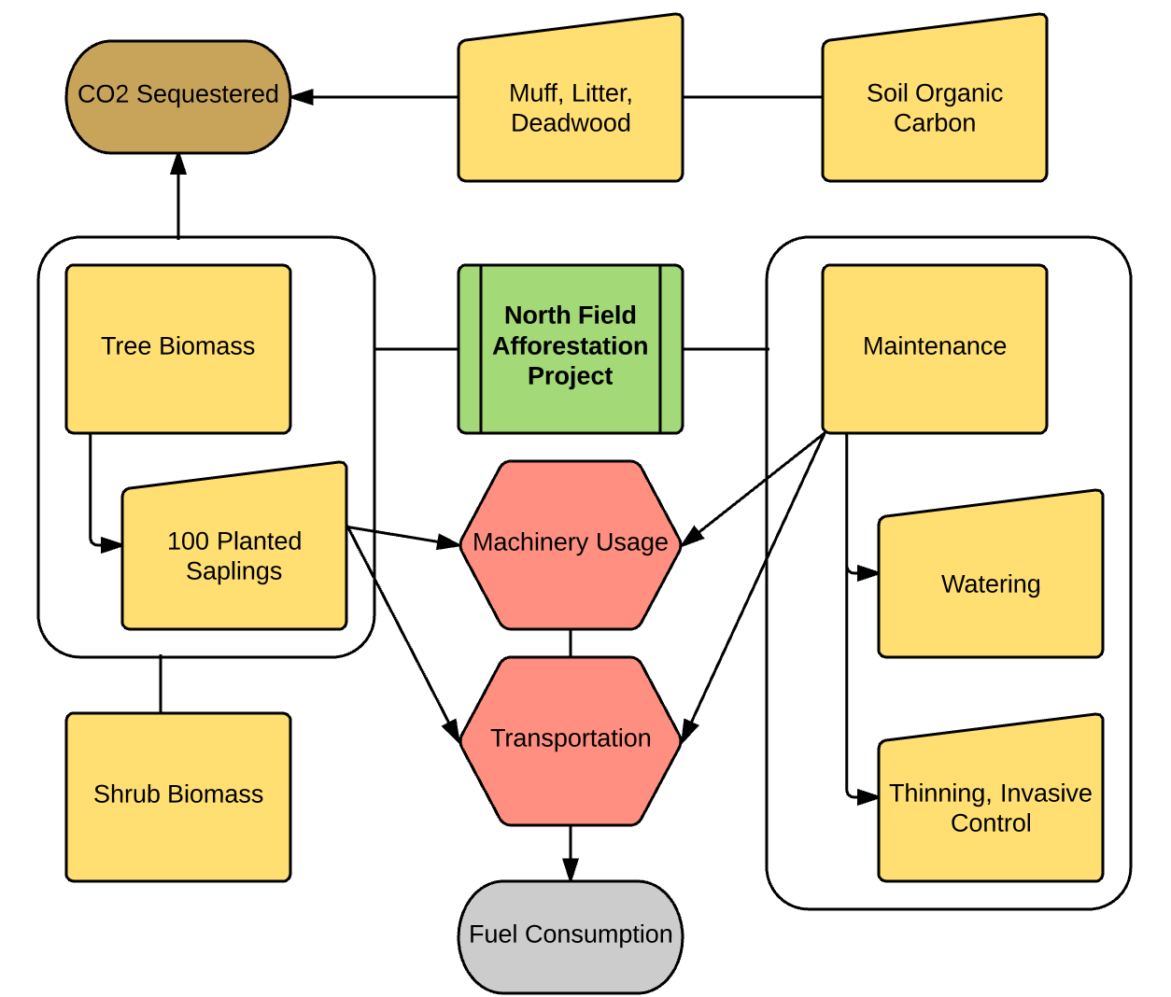

Project SSR List (from map):
Identified SSR | Controlled/ Related/Effected | Different from Baseline? | Rationale for Inclusion or Exclusion | Project Impact (tCO₂e)
Tree Biomass (above and belowground) | Controlled | Yes | Included: Largest SSR | 1209.88
Shrub Biomass | Controlled | Yes | Included: Large source of sequestration | 185
Soil Organic Carbon | Controlled | Yes | Excluded: optional source of emissions | -
Muff, Litter, Deadwood | Controlled | Yes | Excluded: optional source of emissions | -
Maintenance | Controlled | Yes | Excluded: Below de minimis threshold | -
Site Preparation | Controlled | Yes | Excluded: Below soil disturbance threshold | -
Transportation | Related | Yes | Excluded in line with afforestation protocol | -

Determination of Baseline Scenario
Product or Service Granted by Project Activity:
The project scenario provides land management, maintaining and increasing the property value of the project site, which is the critical requirement for the project site according to initial conversations with the Project Owners and Maintainers.
Geographic Area and Temporal Range:
The physical area is the area demarcated in the project aerial Figure 1. To determine the baseline scenario, the temporal range from 2013 when the sapling plantings occurred was evaluated projecting 20 years into the future based on interviews with Facilities and Grounds Managers. These interviews dictated that the area would be managed as meadow over this time period.
Additional Criteria:
The college’s cross-country course, which presently runs through the project site, was preferred to remain in its present location and not require re-routing.

Baseline Candidates:
- Managed Meadow (w/ Simulated Burning)
  - Existing practice of management on project site: area is managed through control of invasive species through spot control: mowed twice annually to simulate a meadow habitat.
  - The meadow scenario provides land management practices and increases property value by improving soil structure and nutrient levels.
- Athletic Fields for Oberlin College
  - Potentially, the athletic department of Oberlin College could decide additional athletic fields are needed. This would require initial leveling, regular mowing, and a large scale upfront investment.
  - The Athletic Fields scenario would ensure land management, requiring additional attention beyond the existing practice. This scenario would increase property value.
- Re-Leasing as Farmland
  - Before the present management practice, simulating a meadow environment, the project site was agricultural land and was leased to a farmer who owns adjacent plots of land. This scenario would involve re-leasing the farm back to this or another farmer. One complication with this option is that in 2012, a large portion of the land previously leased, became occupied by a large solar array. The other impediment to this option is the cross country track runs along the edge of this space and would require re-routing should the land be re-leased for farming.
  - Re-Leasing the project site would accomplish the goals of land management and maintaining property values.
- Project Scenario: Afforestation
  - Through planted saplings and self-recruited trees, the project site will be allowed to grow into forested area. This will provide a living classroom for Oberlin College students and grant co-benefits to the surrounding area.
  - Land management would be maintained and verified by Peer Review network verifiers, additionally the land’s property value would increase, although carbon offset contract’s signed prevent changes to the carbon stock providing recourse to maintain the reduction of atmospheric greenhouse gasses should Oberlin College require to sell this land.
Barrier’s Test Results:
Barrier’s Test: N. Fields Afforestation | Economic | Social | Political | Overall Barriers Assessment (Small, Medium, Large)
Managed Meadow | None – Minimal maintenance | None – existing practice | None – existing practice | No Barriers
Athletic Fields | Large upfront expense | None – no shortage of fields | None – alumni donations boosted by athletics | Large – Multi-million dollar project to construct athletic fields
Re-Leasing as Farmland | Positive Incentive – Rental income | Small – previously removed from farming, could happen again | Large–previous internal decision made to change use of land: solar array | Large – conflicts with current land uses that are long-term in nature
Project Scenario | Small – Upfront cost of saplings & site prep | None – no conflicts | Small – long-term land management contract for carbon pools | Small – Upfront cost and long-term contract pose project barriers

Baseline Scenario Selection: Managed Meadow
Project Scenario Additionality: The Project Scenario is additional beyond the Baseline Scenario by providing funding to unlock the project scenario through purchasing saplings, and providing the labor (paid and volunteer) to prepare the site for afforestation and mark it with appropriate signage. Additionally, the carbon offset program – the Carbon Management Fund – enabled this project to materialize building the structure to qualify this project towards Oberlin College’s carbon neutrality commitment. Further, additionality also resulted from the Carbon Management Fund’s efforts navigating the political landscape of Oberlin College’s Administration to secure a long-term contract that will protect the project sites’ carbon pools over the 40-year project crediting period and for 40 years beyond the project crediting period. The efforts and funding provided by the Project Proponents and the Carbon Management Fund enabled the project to occur and therefore fulfill additionality.

Baseline Scenario SSR List
Baseline Scenario SSRs | Controlled / Related / Effected
Meadow Vegetation – Sink | Controlled
Mowing Tractor – Source | Controlled
Soil Organic Carbon – Reservoir | Controlled

Unchanged Project-Baseline Scenario SSRs
Project: | Baseline:
None | None

All sources must be calculated as all SSRs are different between the project and baseline scenario.

Project Scenario Updated SSRs to Monitor or Estimate
Identified SSR | Different from Baseline? | GHG Impact (tCO₂e) | Rationale for Inclusion or Exclusion* | Monitor or Estimate?
Tree Biomass | Yes | 1209.88 | 85% included: largest source of project impact | Estimate
Shrub Biomass | Yes | 185 | 13% included: substantial impact | Estimate
*Note: percentages equal portion of total project impact over crediting period rounded to nearest %’s.

Baseline Scenario SSRs to Monitor or Estimate
Baseline Scenario SSRs | GHG Impact (tCO2e) | Rationale for Inclusion or Exclusion | Monitor or Estimate?
Meadow - Vegetation | - | Excluded: not a long lasting carbon sink | Estimate
Mowing Tractor | 35.84 | <3% excluded, de minimis source of emissions | N/A
Soil Organic Carbon | - | Excluded: optional source of emissions | N/A

Additional Clarification & Rationalization of SSR Selection:
The baseline scenario excludes soil organic carbon from calculation as it is an optional source of emissions for calculation within this protocol.
Risk Assessment & Future Consideration
Project Permanence:
Project permanence is a key consideration with afforestation projects as forests are prone to risks which threaten project reversal. Non-natural risks to project success include Financial Risk and Project Management risk which each hinge on the Project Owner’s financial solvency over the project’s lifespan (project crediting and post-crediting reversal monitoring) and the continuation of management practices over that timeframe as well. These are risks that face the majority of carbon offset projects, and especially afforestation projects due to their long timeframes. The risks of wildfire, disease, pests, and other natural disaster events (drought, tornadoes, storms, flood, earthquakes etc) also present considerable risk to project permanence despite efforts to reduce these factors through native species selection, and preventative management practices. Risks are evaluated by the ACR Tool for Risk Analysis and Buffer Determination and presented below:
Financial 4%
Project Management 4%
Social/Policy 2%
Fire (low risk area) 2%
Disease and Pests (no epidemic disease or infestation in area) 4%
Other natural disaster events 2%

TOTAL RISK FACTOR = 18%

To counter these risks, a conservative and generous buffer pool will be kept on reserve in case project reversal occurs in proportion with this Total Risk Factor.

Additional Risks:
Leakage – The risk of leakage is small for this project. The largest risk of leakage comes from firewood gathering, but this practice is unlikely to impact the GHG assertion as the land is far from Oberlin College students, and is bordered on the North and West by college leased farmland. There are no communities reliant on the project area for forest products of any kind.
Double Counting – Although the project site is owned and operated by Oberlin College (the project’s intended recipient of the carbon offset credits), the GHG emissions inventory of Oberlin College does not incorporate any land-cover or terrain based calculations for measuring the campus as a net sink of carbon. If the campus is calculated as a carbon sink at some point in the future, the risk of double counting the impact of this project would become an issue and require additional documentation to ensure double counting does not occur.
Buffer Pool Designation & Total Project Risk Factor (as percentage):
The project factors in 18% overall risk of project reversal or failure. The buffer pool designation is therefore 18% of annual reduction of atmospheric GHGs, which is estimated to be 251.06 tCO₂e over the project crediting period, based upon the projected impact of the project. Below is the projected contribution by project year:
Project Years | Estimated Annual Buffer Pool Contribution
1-5 | 2.78
6-10 | 3.49
11-15 | 4.31
16-20 | 4.84
21-25 | 5.02
26-30 | 7.01
31-35 | 10.59
36-40 | 12.17

This estimated buffer pool designation will be updated upon verifications and through monitoring events.

Project Impact Calculation

Global Warming Potentials Used:
CO₂ = 1; CH₄ = 25; N_{x}O = 298. No other gases are relevant for this project.

Baseline Scenario Total Atmospheric GHG Impact:
The baseline scenario sequesters carbon through the vegetative matter of the grasses present, and organic matter stored in the soil. This vegetative matter does not constitute a long-term sink of carbon as these species are short-lived, storing the majority of their carbon in soil organic matter. Through this protocol soil organic carbon is considered an optional source and excluded from calculation for this project. Therefore, the baseline scenario represents a positive release of GHGs into the atmosphere through previous site maintenance as managed meadow, with simulated burning using a 50hp New Holland tractor, which runs on recycled vegetable oil and prior to the project, was operated to mow the project site twice annually consuming an estimated 56 gallons of fuel annually.
Vegetable oil combustion emissions factors provided by EPA 2014: 0.00979 tCO₂ + 0.00325 tCH₄ + 0.00298 tN_{x}O = 0.016 tCO₂e per gallon
Annual Mowing Emissions:
0.016 tCO₂e per gallon * 56 gallons = 0.896 tCO₂e
Total Added Project Impact
0.896tCO₂e * 40 years of crediting period = 35.84 tCO₂e
NOTE: The above sample calculation is not included in the calculation of project impact as it does not exceed the de minimis limit (<3% of total project emission impact.)

Project Scenario Total Atmospheric GHG Impact:
1,394.80 tCO₂e removed
GHG Assertion:
(1,394.80 – (0)) * (1 – 0.18) = 1,143.74 tCO₂e removed
[(Project Scenario – Baseline Scenario) * (1 – Total Project Risk Factor) = GHG Assertion]

Calculation Procedure & Explanation:
Tree Biomass Quantification Methodology
The project site sits adjacent to a 45-acre forest area to its north, west and east estimated to be 55-years old and formerly used as agricultural land similar to the project site before being allowed to naturally succeed to forest (Radulski et al 2013). The project site is expected to have similar species composition to the adjacent forest due to self-recruitment seed availability resulting from the proximity of the adjacent forest, as well as the similarity of species within the selected 100-saplings planted. Through measurement of this adjacent forest Radulski et al (2013) have produced a locally viable growth model that is applicable to the project site and will be used as the project site’s growth rate. Radulski et al (2013), was later revisited, expanding the sample size and reinforcing the findings, by Charkrabarti et al (2015). Both reports were completed by Oberlin College students in an on-going study of the project site and its adjacent forest and are listed for reference in Appendices _-_.
Radulski et al. (2013), estimated based on tree core data that the forest age was approximately 55-years. Therefore, for the purposes of a growth estimate for the North Fields Afforestation project, we treat their analysis of the adjacent forest as a growth model for the project site with the estimated growth between year 56 and 55 for the adjacent forest ago being equivalent to the growth rate in year 1 of the project site. This is a conservative growth model as the data from year 55 of the study by Radulski et al. (2013) excludes carbon stored by trees that deceased between study year 55 and 2013, the year of the analysis. There were likely trees, over this 55-year time-period, that were shaded out by other trees, or for other reasons did not survive to be surveyed in 2013. These trees still added to overall stored carbon levels in the forest through their below ground root biomass and deposition of carbon through decomposition therefore adding additional conservativeness in this carbon storage estimation methodology.
Following Radulski et al. (2013)’s estimation procedure, belowground carbon was estimated based on a generalized approach as measurement and sampling was unfeasible. Radulski et al. (2013) used the following approach:
“Belowground tree biomass is estimated to make up 15.5% of total tree biomass in hardwood forests in the Northeast and North Central regions of the US (Birdsey 1992 after Koch 1989). We therefore divided the calculated aboveground carbon stock of each tree by 0.845 to determine the estimated total tree carbon stock, and we then multiplied this value by 0.155 to approximate the belowground carbon stock.”
Annual Estimated Project CO₂ Removed from the atmosphere and stored as carbon by the afforestation project over the crediting period, including both above and belowground carbon in the trees is averaged in-line with 5-year verification periods:
Project Year | CO₂ Removed by trees over 5-year period (tonnes) | Average Annual CO₂ Removed (5-year average)
1 – 5 | 31.10 | 6.22
6 – 10 | 50.60 | 10.12
11 – 15 | 73.50 | 14.70
16 – 20 | 88.10 | 17.62
21 – 25 | 139.55 | 27.91
26 – 30 | 194.75 | 38.95
31 – 35 | 294.25 | 58.85
36 – 40 | 337.95 | 67.59
Total Impact | 1209.80 | 1209.80

Shrub Quantification Methodology
Shrub growth is calculated using the CDM Methodological Tool: Estimation of carbon stocks and change in carbon stocks of trees and shrubs in A/R CDM project activities) to estimate the carbon stock in time t for the shrubs.
At present the project site is dominated by short-lived grasses and not expected to maintain these stores of carbon over the project period. While at present, the shrub layer has not yet established, it is anticipated that as the forest successional process progresses, the shrub layer will develop within the first 20 years of the project. Estimating a conservative level of shrub crown cover in project year 40, therefore calculating only those sources of carbon that will persist by the end of the project crediting period we can make a conservative estimate of carbon stored in the shrub layer over the project. At the end of the project crediting period, the forest should have <20% crown cover consisting of shrub type biomass therefore 20% is our conservative estimate for crown cover in project year 40. Using the CDM methodological Tool, the shrub layer will add 185 tonnes of CO₂ to the project impact.
At this present level, for 2016, the shrub stratum is zero. We anticipate the shrub stratum to develop over project year 0 to year 20 when it will likely exceed the year 40 quantity of crown cover, but will subsequently begin to be reduce to the year 40 shrub crown cover quantity as tree growth shades out the shrub layer. This estimation is reliant on the crown cover of shrubs within the project site and will be re-calculated in line with project monitoring events. The shrub layer growth per year will be averaged over year 0 to year 20 adding 9.25 tCO₂e annual sequestration to the project impact over that time-period.
Project Year | Average Annual CO₂ removed by trees (5-year average) | Annual CO₂ removed by shrubs | Total CO₂ removed over 5-year period (tonnes)
1 – 5 | 6.22 | 9.25 | 77.35
6 – 10 | 10.12 | 9.25 | 96.85
11 – 15 | 14.70 | 9.25 | 119.75
16 – 20 | 17.62 | 9.25 | 134.35
21 – 25 | 27.91 | 0 | 139.55
26 – 30 | 38.95 | 0 | 194.75
31 – 35 | 58.85 | 0 | 294.25
36 – 40 | 67.59 | 0 | 337.95
Total Impact | 1209.80 | 185 | 1394.80

Optional Sinks:
No optional sinks have been selected for measurement or estimation through this project.

Manage Data Quality (Internal Review)
This document was created by Tomorrow’s Climate Solutions LLC and reviewed internally by Oberlin Project Staff as well as externally by Duke University’s Duke Carbon Offset Initiative Staff providing an initial level of validation.

Data & Measurement Uncertainty:
The data for the basis of the project impact calculation is the product of peer-reviewed literature informed methodologies and very conservatively applied growth models. There is perhaps small amounts of uncertainty that exist within these initial calculations, but the project calculations have been performed conservatively such that subsequent verification of the project’s impact are expected to return greater than projected amounts of stored carbon. Measurement error is low and methodologies are conservative reducing the project data uncertainty.

Information Management System:
Project information will be stored according to the IMS Instructions Document located in the google drive of cmf@oberlin.edu. According to this procedure, all files will be saved within the google drive folder: Active Projects > Afforestation and files names will follow the conventions as detailed in the IMS Instructions naming files: “filename_date of last update”.

Project Monitoring Plan

Data for Collection:
Specific SSR | Monitored or Estimated? | Data Source | Collection Method | Responsible Party (for data collection)
Tree Biomass | Estimated | Sample data to include: DBH, species, height, & estimated age | In-person on-site measurement | Office of Environmental Sustainability
Shrub Biomass | Estimated | Biomass stratification and crown cover estimation | In-person on-site estimation | Office of Environmental Sustainability

Schedule of Calibration for Direct Monitoring:
No calibration is required to perform the monitoring schedule.

Conditions for Data Monitoring:
Monitoring activities should be performed when the afforestation site has foliage existing on trees and shrubs for the purposes of accurately estimating crown cover percentages and stratification. This can typically be met by monitoring in the Spring, Summer or Fall.

Data Collection & Monitoring Methods:
Standard practices will be applied when taking DBH measurements, when identifying species, when estimating height and age, and when assessing crown cover in accordance with the CDM A/R Methodological Tool: Calculation of the number of sample plots for measurement within A/R CDM project activities V02.1.0 or following the guidance of other peer-review approved literature provided a rationale of the methodology applied is provided.
Annual walk-through surveyors must educate themselves prior to performing walk through duties, regarding project & prescribed forest management practices as well as to identify possible disturbance events (fire, pests, natural disaster, disease etc).

Project & Baseline Monitoring Schedule:
Project Timeline | Monitoring Event Type | Data Collected
Start Date – once completed: | Stratification | Biomass stratification; if trees planted: species, DBH, height, estimated age, (GPS coordinates)
Years 1-4 | “Walk-through” survey | Ensure Natural Management Practice, Identify Disturbance Events
Year 5 | Full inventory | Representative sampling: Species, DBH, height, estimated age, (GPS coordinates)
Years 6-9 | “Walk-through” survey | Ensure Natural Management Practice, Identify Disturbance Events
Year 10 | Full inventory | Representative sampling: Species, DBH, height, estimated age, (GPS coordinates).
Years 11-14 | “Walk-through” survey | Ensure Natural Management Practice, Identify Disturbance Events
Year 15 | Full inventory | Representative sampling: Species, DBH, height, estimated age, (GPS coordinates)
Years 16-19 | “Walk-through” survey | Ensure Natural Management Practice, Identify Disturbance Events
Year 20 | Full inventory  Recalculation of baseline scenario | Representative sampling: Species, DBH, height, estimated age, (GPS coordinates). Pertinent laws, common practice and other information to determine baseline suitability.
Years 21-24 | “Walk-through” survey | Ensure Natural Management Practice, Identify Disturbance Events
Year 25 | Full inventory | Representative sampling: Species, DBH, height, estimated age, (GPS coordinates)
Years 26-29 | “Walk-through” survey | Ensure Natural Management Practice, Identify Disturbance Events
Year 30 | Full inventory | Representative sampling: Species, DBH, height, estimated age, (GPS coordinates).
Years 31-34 | “Walk-through” survey | Ensure Natural Management Practice, Identify Disturbance Events
Year 35 | Full inventory | Representative sampling: Species, DBH, height, estimated age, (GPS coordinates)
Years 36-39 | “Walk-through” survey | Ensure Natural Management Practice, Identify Disturbance Events
Year 40 | Full inventory | Representative sampling: Species, DBH, height, estimated age, (GPS coordinates).

Project Verification
Verification will be carried out through the Peer Reviewed Network by a peer-institution with an experienced but non-accredited verifier. According to the Afforestation Protocol, this selection for verification type adds 5% to overall project uncertainty, which has been added into the calculation of the GHG Assertion. It should also be noted that the guidelines for verification are still in development for inclusion within the Carbon Commitment. The program is presently in its trial phase while all necessary accounting components are structured to provide robust and reliable carbon offsets. This Project Description Document therefore documents the existence of this project, but must await further development within the Carbon Commitment guidance and structures before being counted to offset emissions for Oberlin College.

Document Author(s) & Contact
The author(s) of this document, Tani Colbert-Sangree, attest that they have performed duties regarding the accounting documentation required within this document with complete honesty and truthfulness. The signature below certifies that the authors did not intentionally misrepresent or present information in misleading ways through this document.
Author Signature:_____________________________________________
The author(s) welcomes your comments and invites you to be in communication. Please contact them at tani.colbertsangree@gmail.com

Appendices

Appendix 1: Project Impact calculation based on the following reports
Charkrabarti et al, (2015). Systems Ecology Class Research Project. URL:
Radulski et al, (2013). Systems Ecology Class Research Project. URL:
Additional explanation of methods:
Radulski et al 2013 took DBH measurements from 85 trees along 3 transect lines within the adjacent forest to the north of the project site. Tree cores were taken from 12 of the 85 trees measured. Using the “Lambert Equations for biomass, no Foliage” above-ground biomass and carbon content was calculated applying the measurements of DBH. Although additional equations were used returning higher stored carbon values in line with the conservatism principle, the results of the “Lambert Equations for biomass, no Foliage” will be utilized.
Radulski et al (2013) produced an estimate for the adjacent forest’s above-ground biomass accumulation and the rate of growth. Applying Lambert’s measured proportion of below ground Tree Biomass which he reports as 15.5% of Total Tree Biomass, the estimates of Radulski et al. (2013) were increased by 15.5% to incorporate below-ground carbon establishing a total carbon accumulation rate for the entire 45-acre adjacent forest. This estimate for the 45-acre adjacent forest was then scaled to the project area applying the proportionality ratio of project area to adjacent forest: 8.86 acres/45 acres. This rate of carbon accumulation, which includes both above and below-ground carbon, was then converted from C to CO₂ multiplying by 44/12. Values presented in this document have been averaged over a 5-year time period to reflect increasing growth rates as tree stands develop, while also providing consistent numbers to ease calculations without diverging much from the original values.

Appendix 2: Forest Management Plan

CAR, 2012. Forest Project Protocol Version 3.3. Climate Action Reserve. Climateactionreserve.org. Accessible via: http://www.climateactionreserve.org/how/protocols/forest/dev/version-3-3/
CDM, 2013. AR-AMS0007: Afforestation & Reforestation Project Activities implemented on lands other than wetlands version 3.1. Clean Development Mechanism of the United Nations Framework Convention on Climate Change. Cdm.unfccc.int. https://cdm.unfccc.int/methodologies/DB/J6ZHLX1C3AEMSZ52PWIII6D2AOJZUB
IPCC, 2006. IPCC Guidelines for National Greenhouse Gas Inventories, Chapter 4: Forest Land. IPCC-nggip.iges.or.jp. http://www.ipcc-nggip.iges.or.jp/public/2006gl/pdf/4_Volume4/V4_04_Ch4_Forest_Land.pdf
American Carbon Registry, 2009. The American Carbon Registry Forest Carbon Project Standard Version 1. www.responsiblepurchasing.org. http://www.responsiblepurchasing.org/purchasing_guides/carbon_offsets/standards/American_Carbon_Registry_Forest_Carbon_Project_Standard.pdf
ODPS Ohio Emergency Management Agency, 2014. State of Ohio Hazard Mitigation Plan: Section 2.7. www.ohio.gov. http://ema.ohio.gov/Documents/OhioMitigationPlan/SOHMP_Sec_2_7.pdf Note: According to the ODNR Division of Forestry’s State of Ohio Wildfire Hazard Assessment, Afforestation Project Sites eligible within this protocol are all within Ohio’s low risk wildfire regions: 1 & 2. Page 160 provides a raster based map outlining the risk of wildfire on a township by township scale.
Data estimated by Grounds Manager Dennis Greive 9/1/16. Oberlin College Grounds Manager. http://new.oberlin.edu/office/facilities-operations/staff_detail.dot?id=233335
EPA, 2014. Emissions Factors for Greenhouse Gas Inventories. Environmental Protection Agency. www.epa.gov https://www.epa.gov/sites/production/files/2015-07/documents/emission-factors_2014.pdf
CDM, 2015. Estimation of carbon stocks and change in carbon stocks in trees and shrubs in A/R CDM project activities version 4.2. Clean Development Mechanism of the United Nations Framework Convention on Climate Change http://cdm.unfccc.int/methodologies/ARmethodologies/tools/ar-am-tool-14-v4.2.pdf
Mouer, Melinda (1985). COVER: a User’s Guide to CANOPY and SHRUBS Extension of the Stand Prognosis Model. United States Department of Agriculture: Forest Service. http://www.fs.fed.us/fmsc/ftp/fvs/docs/gtr/cover.pdf

