Project Protocol:

Afforestation
Version 1.4 January 16th, 2017
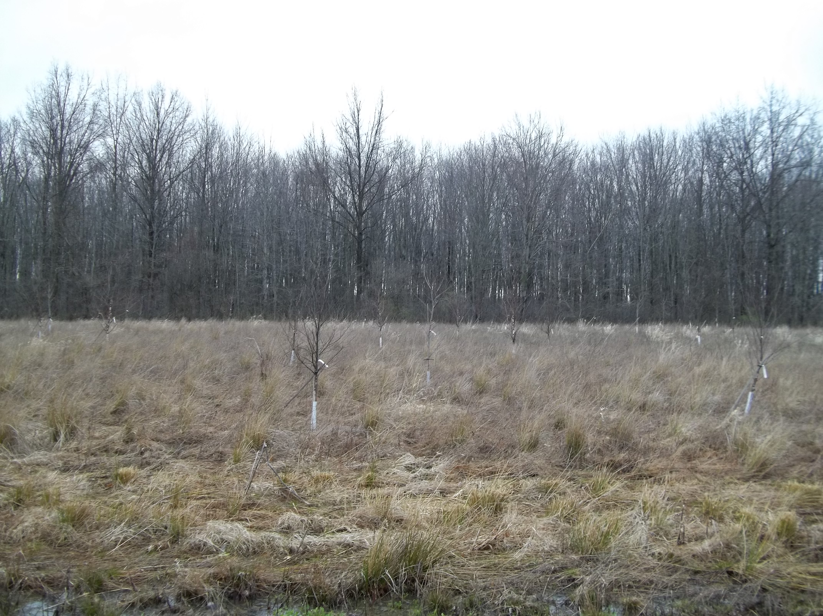

Table of Contents
1. Protocol Overview 3
1.1 Scope 3
1.2 Protocol Developer 3
2. Protocol Description 4
2.1 Accredited Program Reference Literature 4
2.2 Forest Carbon Offsets 4
2.3 Co-Benefits of Afforestation 4
2.4 Project Participants 5
3. Eligibility Conditions 6
4. Procedure for Demonstrating High Quality Offsets 9
5. Procedure for Determining Additionality 11
6. Stratification of Biomass 11
7. Procedure for Determining the Baseline 11
8. Risk Analysis & Buffer Determination 12
8.1 Leakage 12
8.2 Crediting 13
9. Quantifying Net Greenhouse Gas Emissions Reductions and Removals 13
9.1 Tree Growth 14
9.2 Shrub Growth 15
9.3 Optional Carbon Sinks 16
9.4 Fire 17
9.5 Data & Measurement Uncertainty 17
10. Project Monitoring 17
10.1 Monitoring Report 19
10.2 Information Management System 20
11. Verification Requirements 20
11.1 Verification Requirements 20
11.3 Verification Timeline 21
12. Appendices 21
12.1 Protocol Developer’s Background Info 21

1. Protocol Overview

1.1 Scope
This protocol provides the procedure for determining the carbon dioxide equivalent (CO₂e) storage associated with afforestation projects, as part of efforts by signatory schools towards the Carbon Commitment. For purposes of this protocol, an Afforestation project is one that seeks to build forest cover in an area not currently forested. Any reforestation or other forest project that meets the eligibility requirements stated in Section 3 of this protocol qualifies to use this protocol’s methodology as well.

The Afforestation Protocol will be used in coordination with the General Protocol (for carbon offset project accounting) to facilitate the accounting for small-scale carbon offset projects, local to Colleges and Universities. For purposes of this protocol, in line with the Carbon Commitment Guidance for Peer Reviewed and Innovative Offset Projects, total emissions offset by Peer Reviewed or Innovative Offset projects may presently only target Scope 3 emissions and may not exceed 30% of total inventoried emissions.

Compliance with this protocol enables inclusion within Second Nature’s Peer Review Network and Carbon Commitment program, allowing institutions greater flexibility in achieving their carbon neutrality goals. This protocol is applicable for non-wetlands within the Northern Ohio biome.

1.2 Protocol Developer
This protocol was adapted from Duke University’s Urban Forestry Program as part of the Duke Carbon Offsets Initiative, through the consultant services of Tomorrow’s Climate Solutions LLC. For more information regarding the Protocol Developers see Appendix, section 12.1.

Authors
Primary Author, Tomorrow’s Climate Solutions:
Tani Colbert-Sangree, TCS Principal

Duke University:
Charles Adair, DCOI Program Manager
Jason Elliott, DCOI Program Coordinator
Alec Brown, DCOI Urban Forestry Research Assistant

Contact Information
Tani Colbert-Sangree
Tomorrow’s Climate Solutions
tani@tomorrowsclimatesolutions.com

2. Protocol Description
This forestry carbon offset protocol (“Protocol”) outlines the methodology for developing and measuring the carbon offsets generated from afforestation projects. This protocol should be used to ensure that the carbon offsets generated from the project meet the basic criteria of a carbon offset:

Permanent – The reduction must last in perpetuity;
Additional – The reduction would not have occurred during a business-as-usual scenario;
Verifiable – The reduction must be monitored and confirmed to have occurred;
Enforceable – The reduction must be counted only once and then retired; and
Real – The reduction must actually have occurred, be measureable, and not be the result of flawed accounting.

2.1 Accredited Program Reference Literature
This protocol adapts various requirements and definitions from the Climate Action Reserve’s (CAR) Forest Project Protocol Version 3.3 for reforestation projects, the Verified Carbon Standard (VCS) eligible Clean Development Mechanism (CDM) Methodology Protocol A/R Small-scale Methodology: Afforestation and reforestation project activities implemented on lands other than wetlands (AR-AMS0007), the 2006 IPCC Guidelines for National Greenhouse Gas Inventories: Volume 4: Agriculture, Forestry and Other Land Use, and The American Carbon Registry’s Forest Carbon Project Standard. Depending on future circumstances, or potential regulatory changes this protocol may be adjusted in line with the protocol creation process as guided by relevant governing bodies.

2.2 Forest Carbon Offsets
Forests sequester carbon by fixation of carbon dioxide (CO₂) through photosynthesis. Assuming forest trees are healthy and properly managed, this carbon is accumulated and stored throughout the life of the forest, thus serving as a carbon sink. Returning an area to natural forest stores carbon through the accumulation of carbon in trees, the soil, shrub and herbaceous growth in the forest’s understory, dead wood accumulation, and leaf litter from dead plant material. Afforestation projects may include trees physically planted, as well as trees that self-recruit when allowed to mature through a change in management practices.

2.3 Co-Benefits of Afforestation
In addition to storage of carbon, forests provide many other health, environmental, and economic benefits. Trees reduce air and water pollution, reduce erosion, absorb agricultural run-off, provide habitat and food for animal populations and pollinators, give refuge to migratory species, provide wind breaks, and increase the resilience of nearby settlements. This section highlights the categories to consider when assessing the additional co-benefits of an afforestation offset project.

Education—Afforestation can provide the following educational co-benefits:
  - Offer students an opportunity to develop a carbon offset project
  - Offer students and faculty research opportunities to develop afforestation guidance in the context of climate change adaptation
  - Provide volunteering opportunities to learn forest management practices
  - Inform community members about the benefits of additional forest
  - Help develop curriculum about the life and measurements of forests

Social—Afforestation can provide the following social co-benefits
  - Engage local communities and neighborhood to host tree planting events
  - Provide emotional and physiological health benefits by increasing access to forests

Environmental —Afforestation can provide the following environmental co-benefits:
  - Remove harmful pollutants from the atmosphere
  - Reduce storm water runoff
  - Reduce heat island effect and create wind breaks
  - Offer habitat for native and migratory species

Economic – Investments in afforestation can provide the following economic co-benefits:
  - Increase property values of land with forest and homes with access to forest
  - Reduce building energy bills by reducing heating and cooling needs
  - Provides a high return-on-investment when ecosystem services are aggregated

Scalability—Afforestation projects have great flexibility in their implementation. Provided land ownership is assured, afforestation projects can take place so long as the owner complies and cooperates, reducing the implementation barriers and granting afforestation projects the ability to scale.

Public Relations and Partnerships—Afforestation can be a highly visible community engagement project. When afforestation is done on public land and for public use it may require the collaboration of a variety of stakeholders from municipal employees to neighborhood associations to companies looking to engage the community in a lasting, powerful way within a community shared space.

2.4 Project Participants
Afforestation Site Owner
(“Owner”) is a corporation, a legally constituted entity (such as a utility or special district), city, county, state agency, educational campus, individual(s), or a combination thereof that has legal control of any amount of afforestation carbon within the Project Area. Control of afforestation carbon means the Afforestation Site Owner has the legal authority to effect changes to urban forest carbon quantities (for example, right to plant or remove). Project reversals are therefore the purview and responsibility of the Site Owner. Control of afforestation carbon occurs, for purposes of satisfying this protocol, through fee-ownership-based contractual agreements, and/or deeded encumbrances. This protocol recognizes the “fee owner”, who has rights to effect changes to the urban forest carbon quantities, as the default owner of afforestation carbon where no explicit legal encumbrance exists. Individuals or entities holding mineral, gas, oil, or similar de minimis interests without fee ownership are precluded from the definition of Afforestation Site Owner.
Afforestation Project Proponent
(“Proponent”) must contract with the Owner to obtain ownership of the afforestation carbon created from the project. The Proponent is thereby responsible for project quantification, monitoring, reporting, and contracting with a third-party to verify the carbon. In all cases where multiple Owners participate in an Afforestation Project, the Project Proponent must secure an agreement from all other Owners that assigns ownership of the afforestation carbon to the Project Proponent.
Afforestation Site Maintainer
(“Maintainer”) is an entity responsible for maintaining the health of all project trees across the project timeline. Project Maintainers can be the Owner, municipal tree crews, contractors, or volunteers trained in best industry practices such as Natural Forest Management. The Maintainer, Proponent, and Owner may share monitoring responsibilities for disturbance events and the compliance of management practices with assigned responsibilities outlined in the Project Description Document (General Protocol).

3. Eligibility Conditions
This protocol uses the following eligibility conditions informed by the CAR Forest Project Protocol, and the CDM A/R Small-scale Methodology: Afforestation and reforestation project activities implemented on lands other than wetlands.
Any Afforestation Project shall meet the following conditions:
Project Location
Afforestation Projects must be within the Carbon Commitment local project designation by adhering to at least one of the following definitions of local:
- Accessible by students from the College or University from which Afforestation Project funds originated without requiring greater than 1 day of travel roundtrip to visit the project site;
- Within the same State as the College or University;
- Within 100 miles of the College or University Campus.
Project Area
The Project Area is the geographic extent of the Afforestation Project. The Project Area may be made of consolidated or disaggregated polygons. A Keyhole Markup Language (KML) file or similar map file must clearly identify the project boundaries. No part of the Project Area can be included if commercial harvesting of timber has occurred in the Project Area in the past 10 years (CAR).
Project Commencement
The commencement date, or project initiation date, is the “Start Date” of the project for project impact estimation purposes. Within this protocol, project commencement, and carbon accumulation for the purposes of generating carbon offsets, formally begins once the project’s initial estimation and “full inventory” accounting have been completed. Once an Afforestation Project has commenced, new plantings can occur within the Project Area over the Project’s life.
Additionality
The Project must yield surplus GHG emission reductions and removals that are additional to what would have occurred in the absence of a carbon offset program. The protocol requirements for determining eligibility are listed in the section “Procedure for Determining Additionality.”
Legal Requirement
Afforestation Projects must achieve GHG reductions or removals above and beyond any GHG reductions or removals that would result from compliance with any federal, state, or local law, statute, rule, regulation, or ordinance. At the Afforestation Project’s initial validation, required before or during project year 2, the Project Proponent must sign the Attestation of Voluntary Implementation form indicating that the project’s afforestation activities are not legally required (as defined above) and were not legally required at the time of the project’s start date, defined as the date that the project site contract governing carbon storage became active.

Deeded Encumbrances
Deeded encumbrances, such as timber deeds or conservation easements, may effectively control forest carbon, such that there may be multiple Afforestation Site Owners within the Project Area. Deeded encumbrances are considered legally binding mandates for the purposes of evaluating additionality beyond the legal requirement.

Deeded encumbrances may contain terms that do not directly refer to forest carbon, but that nevertheless restrict the effect or ability of any Afforestation Site Owner to change forest carbon stocks. These terms must be interpreted with respect to their effect on forest carbon for the purposes of discerning legal requirement and in making the baseline determination. Where the terms of deeded encumbrances are not explicit with regards to forest carbon, the following assumptions shall be made:
- Restrictions or references related to canopy cover, basal area, density, volume, carbon, or biomass apply to standing live and dead trees of all species.
- Carbon in other pools (soil, litter, shrubs, branches, leaves etc) are assumed to be associated with the other defined terms, such as trees, stated within the deed.
- Terms related to forest (tree) growth apply to growth in all species.

Project Crediting Period
The crediting period for an Afforestation Project is 40 years. Projects may be renewed but must calculate an updated baseline before offset generation is continued. The original baseline may be held throughout the 40-year crediting period. An updated baseline must reestablish project additionality and ensure that no new laws or regulations have been passed impacting the project.
Minimum Time Commitment
Projects must monitor, report, and undergo verification activities for 40 years following the last credit issued to the project. The timeframe of 40 years was selected in coordination with the Duke Carbon Offset Initiative’s belief that carbon offsets are a bridge to a time in which a lower carbon economy has taken hold.

Forest Management
Afforestation Projects can create long-term climate benefits as well as provide other environmental benefits, including the sustaining of natural ecosystem processes. To be eligible under this protocol, Afforestation Projects must submit Management Practices that at a minimum include the below standards of Natural Forest Management (CAR):

  - Forest Diversity: All Forest Projects must promote and maintain a diversity of native species and utilize management practices that promote and maintain native forests comprised of multiple ages and mixed native species within the Project Area.
  - Native Forest: The determination of native forest, must be assessed through written documentation from a qualified independent resource. The project must meet or exceed 95% native species based on the sum of standing live carbon pool (living trees), or detail the management practices that will bring the project area to be within this requirement. Peer reviewed academic research can inform the planting of non-native species within the project area as an adaptation strategy to climate change, but must be accompanied by written statement from the relevant forestry agency, stipulating that the plantings add to the goals of a local, state or federally approved adaptation plan.
  - Diversely Aged: Management Practices that seek to establish a diversely aged forest. No more than 40% of forested acreage should be ages less than 20 years, excluding areas impacted by Significant Disturbance. This criterion must be addressed by management practices and met within 25 years of project start.
  - Zero Harvesting: Either employ a zero-harvesting plan; or, employ sustainable long-term harvesting practices within the Project Area. Forest landholdings are considered controlled by the Project Proponent, if the Project Proponent owns the land in fee, or has been deeded the timber right; otherwise, following the harvesting plan is assumed to be the Afforestation Site Owner’s responsibility. For guidance on acceptable Sustainable long-term harvesting practices refer to CAR: Forest Project Protocol Version 3.32.
  - Increase Standing Carbon: Increase standing live carbon, calculated through project verification (after 5 years). The following exceptions would benefit the health of the forest and long-term carbon storage, despite causing a short-term reduction in the standing live carbon, and are encouraged through Natural Forest Management practices and this protocol:
    - A reduction in standing live carbon resulting from preventative measures to address forest health risks, including: wildfire, insect management, and disease (as well as additional factors provided sufficient justification). If these efforts cause a reduction in standing live carbon beyond management practice estimates, project reversal contingencies and buffer pool considerations would need to address the loss of standing carbon.
    - Although for the purposes of this protocol, these risk factors are considered non-avoidable, good management practices can reduce the buffer pool contribution required if practices can reliably reduce these unavoidable risks.

Site Preparation
The preparation of the site must not remove sources of carbon beyond a reasonable amount from the project area.

- The 3% de minimis threshold, of the project’s estimated GHG impact, is applied in determining whether calculation is required to account for carbon pool reductions due to site preparation (i.e. removal of deadwood or clearing of brush). Site preparation GHG impacts must be estimated to assure compliance with the de minimis threshold.

- Site preparation must further ensure that soil disturbance is limited to a maximum of 10% of total project area, as SOC is released when exposed to the air reducing the carbon stored in the soil of the project area (CDM). Example: 0.5M bore-holes for tree planting spaced at 3x3M intervals within a project area = 2.97% of total project area.

- In some cases, project site preparation may require the use of machinery. In these cases, combustion of fuel through operation and transportation must be accounted for within project site preparation.

Selection of Species for Planting
Projects that involve planting must be in line with the >95% native species criteria in line with Natural Forest Management. Additionally, species must be selected which do not suffer from epidemic disease or pest infestation, at the time of project initiation, within a 30-mile radius of the project area (CDM).

4. Procedure for Demonstrating High Quality Offsets
This section will discuss the components of a high-quality carbon offset with in-depth descriptions of P.A.V.E.R. requirements and co-benefits.

Offset Criteria and Definition | Required Data and Program Procedures
Permanent  The reduction must last in perpetuity and the emission reductions cannot be reversed. | It is important to ensure the longevity and health of the forest area within the program to efficiently store as much carbon as possible. With regards to this protocol, it is required to maintain the forest and stored carbon for at least 40 years beyond the last crediting period. Therefore, if the project commences in the year 2020, and the final credit is granted in the year 2060, the project’s management practices must continue to govern the project site until 2100.  It is important to consider the nature of trees and that they are subject to a variety of stressors. These risk factors include: financial, project management, social/policy, wildfire, disease, pests and natural disasters. These issues pose a risk to project reversal. Therefore, it is important to determine a buffer pool to take these factors into account. For more information on this, please read the “Risk Analysis & Buffer Determination” section.
Additional  The reduction would not have occurred during a business-as-usual scenario | To demonstrate additionality, the project documentation must show that there were significant barriers to designating an area for afforestation, such as funding, internal policy or staff limitations. Project documentation must detail the removal of barriers that led to the designation and growth of additional forest to increase carbon storage. For more information about additionality, please read the “Procedure for Determining Additionality” section of this document.
Verifiable  The reduction must have been monitored and confirmed to have occurred | At a minimum, the required data to ensure verifiability is the height and diameter at breast height (DBH) of the trees to calculate volume and whether or not the tree is alive or dead. This data is needed for each tree or a random sampling of trees. At a minimum, the trees need to be measured every 5 years to ensure that growth patterns match those of projected tree growth. Projected tree growth can be estimated using established forest growth models as outlined in the section included below, “Quantifying Net Greenhouse Gas Emission Reductions and Removals”.  Project Verification for inclusion within the voluntary Climate Leadership Commitment (CLC): Carbon Commitment program may elect to hire an accredited 3rd party verifier, or to rely upon peer institutions to provide external verification for projects. Verification for these projects proceeds in line with the Peer Review Network guidance. Academic peer-review provides validation by an external organization and incentivizes Local Offset projects by reducing verification costs. If verified by the academic community, all data and procedures must be made transparent and available to the public via www.offsetnetwork.org.
Enforceable  The reduction must be counted only once by a single organization and then retired. | After the project impact has been calculated, each individual offset can only be used by a single organization and then retired (i.e. cannot be used again). To properly enforce ownership of offsets, a contract between the Afforestation Project Site Owner and the Afforestation Project Proponent should state which organization(s) receives the offsets and how many offsets are to be given to the organization(s). All projects shall be registered with an existing GHG Registry to provide an added layer of accountability. Additionally, Project Proponents must describe the steps taken to ensure the emissions reductions are not counted within Project Owner emissions inventories.
Real  The reduction must actually occur, be measureable, and not be the result of flawed accounting | A baseline must be established to gauge the impact of a tree planting project. This baseline calculation methodology, the tree measurement data, and the carbon offset calculation methodology should be transparent and made available to the public.

5. Procedure for Determining Additionality
Below is methodological guidance for implementing the Barrier’s Test from the General Protocol for afforestation projects, while additional components are required to establish an Afforestation Project’s CO₂e reductions and removals as additional:

Identify the Implementation Barriers: Survey Afforestation Project Owners to determine what factors are limiting their ability to plant more trees than current baseline.
Removal of Barriers: Ensure the project will remove barriers faced by the Afforestation Project Owners and demonstrate that carbon offset revenues will contribute to project viability.
Calculate a Business as Usual Scenario: If available, use historical data to calculate a baseline. If unavailable estimate the baseline scenario based on peer-review literature. (See: “Procedure for Determining a Baseline”)
Satisfaction of Legal Requirement: Verify that Afforestation Project Owners are not bound by law, regulation, or court order to reforest in the same or similar manner as those prescribed by the Afforestation Project.
Provide Proof of Management Practices and/or Planting Program: Following the Forest Management guidance, demonstrate that project activities are above the calculated baseline through deliberate and documented management practices.
Accounting for Leakage: Typical sources of afforestation leakage, gathering firewood and illegal logging, are uncommon practices within the geographical scope of this protocol. Therefore, atypical leakage factors must be assessed on a project by project basis. Most leakage activities will not present a risk of project reversal, but when high risk leakage is identified by the Project Proponent this risk factor must be included within the proposed monitoring plan, and an additional contribution of 4% will be added to the buffer pool. If no high-risk leakage factors are identified rationalize the absence of leakage from the project within project documentation.

6. Stratification of Biomass
The project site must be stratified by major vegetation types, crown cover and/or land use types, i.e. cut turf, managed meadow, agricultural land, bare/heavy erosion, forest, wetland etc. Stratification facilitates project monitoring as subsequent verifications will update the initial stratification. The baseline scenario’s biomass type(s) must be stratified, and appropriate peer-reviewed literature selected to estimate the carbon stored in substantial sinks within the baseline vegetation separately for each stratified biomass type. Stratification of biomass allows Project Proponents to create a projection of the impact of the baseline scenario to model against the project scenario, and measure the difference between the baseline and project.

7. Procedure for Determining the Baseline
Through the demonstration of project additionality, using the Barrier’s Test procedure from the General Protocol and the supplemental guidance “Procedure for Determining Additionality” from this protocol, all potential Project Site scenarios were considered and listed. The process of performing the Barriers Test accomplishes the goal of substantiating the additionality of the Project Scenario, as well as identifying the Baseline Scenario: the scenario with the least substantial barriers. The scenario with the least substantial barriers is the Baseline Scenario as it would have occurred in the absence of the GHG Program and carbon offset funding.

The Baseline Scenario is calculated every 20 years as specified by monitoring requirements and reviewed by 3rd party sources during verification. The stratification of biomass allows for transparent, verifiable and reproducible results. Peer-reviewed research must be justified for its applicability and applied conservatively to calculate the Baseline Scenario’s GHG impact. While accuracy would be improved through direct measurement of the baseline scenario, through soil sampling and biomass measurement, this would add substantially to project costs and create a barrier to project initiation. Therefore, estimation should be used to establish the baseline scenario when historical data does not exist, as is common GHG accounting practice.

8. Risk Analysis & Buffer Determination
A conservative buffer pool is used to protect against unavoidable, or unforeseen reversals in the project. The risk factor accounts for unintentional project reversals, while intentional project reversals incur appropriate recourse in line with the Afforestation Site Owner & Proponent agreements. This protocol analyzes risk using the ACR Tool for Risk Analysis and Buffer Determination V1.0. Unintentional risk factors included in this determination of project risks include:
Financial 4%
Project Management 4%
Social/Policy 2%
Fire (low risk area) 2%
Disease and Pests (no epidemic disease or infestation in area) 4%
Other natural disaster events 2%

TOTAL DEFAULT RISK FACTOR = 18%

If a conservation easement is in place, the project is eligible for a risk deduction of 2% and an additional 1% of risk is deducted if, within the easement, regular onsite monitoring of carbon specific conservation activities occurs (consult ACR Tool for Risk Analysis and Buffer Determination V1.0 for additional information).

Apply the risk factor through the below formula to assess the buffer pool contribution from the project:
(GHG Assertion per year) * (Risk Factor) = Annual Buffer Pool Contribution

8.1 Leakage
Leakage within afforestation projects could take the form of gathering firewood or unlawful logging, neither of which pose a large risk of project reversal within the context of Ohio where the occurrence of illegal logging is low, and the practice of gathering wood for fuel is uncommon. Unforeseen leakage is included within the Social/Policy risk calculation provided by the ACR Tool and therefore leakage is managed through this 2% addition to the default risk factor.

If high risk leakage is identified through the “Procedure for Determining Additionality”, add 4% to the default risk factor.

8.2 Crediting
Standard Project Crediting:
- Once the project is initiated, Project Proponents cannot purchase or retire offsets until they have been verified to have occurred.
- Once the offsets have been verified (see verification schedule below), the buffer pool contribution is made in accordance with the determined Risk Factor.
- Once verification and buffer pool contribution have been made the offsets may be purchased or retired.
The Peer Review Network reserves the right to adjust buffer pool contributions, in response to changing circumstances during the project lifetime.

9. Quantifying Net Greenhouse Gas Emissions Reductions and Removals
  - Section Disclaimer: This section uses more technical language and requires familiarity with forest based carbon accounting. It is advised that Project Managers work in coordination with Professors of classes with curricular cross-over to develop research projects to quantify project impact, while Staff and outside professionals with forestry expertise should be consulted if beyond existing curricular capacity.
  - NOTE: This section provides methodology for calculating the forest carbon Sources, Sinks and Reservoirs, but the General Protocol section “3.5: Calculate GHG Impact” should be applied to determine project impact beyond the baseline scenario.
Quantification of GHG emissions and removals can be fulfilled either by following the procedure outlined below, which draws from the approved CDM quantification methodological tool: Estimation of carbon stocks and change in carbon stocks of trees and shrubs in A/R CDM project activities to estimate the carbon stored in an afforestation project, or by following a methodology approved by a reputable carbon offset governing body (CDM, VCS, CAR, ACR, or Gold Standard). Afforestation removes carbon dioxide from the atmosphere, but does not have a meaningful impact on other GHGs, except when burned (for guidance on calculating the project impact of fire see the section titled Fire).
To address project accounting for afforestation projects, this protocol designates forest carbon sinks as either required or optional in line with CDM guidance. For the purposes of this protocol, sinks of carbon for estimation include: above ground biomass, and below ground biomass. Optional sinks for calculation include: soil carbon, deadwood, and litter (CDM). While calculation of optional carbon sinks will typically increase the project’s GHG assertion, the additional time commitment of estimation, sampling and accounting may not be worth the potential increase in project impact to the Project Owner or Proponent. It is therefore conservative to eliminate these carbon sinks from project accounting if desired by the Project Owner or Proponent, while management practice requirements restrict GHG releases from these sinks.
Exclude from consideration as per CDM good practice guidance de minimis sources and sinks of GHG emissions that include: “GHG emissions resulting from removal of herbaceous vegetation, combustion of fossil fuel (related to planting), fertilizer application, use of wood, decomposition of litter and fine roots of N-fixing trees, construction of access roads within the project boundary, and transportation attributable to the project activity…” (CDM).

9.1 Tree Growth
The quantification methodology presented below, requires use of the most contemporary, peer-reviewed literature available for calculating tree growth within the project site’s applicable climatic region and its impact on above and below ground carbon sinks. The selection of this literature, and determination of its applicability to the project site must be presented in the Project Impact Calculation section and supplemental reports or studies presented as needed within appendices to the Project Description Document. The project impact calculation should also be included within appendices to allow reproducibility and double checking by the Peer Review Network.
The ex-ante estimation (projection) for the project’s impact can be accomplished without the need for project site sampling by modelling tree growth (above ground carbon sink), root growth (below ground carbon sink), and stand development backed by peer-reviewed literature. Project site sampling is required to confirm the ex-ante estimation during the first project verification. Sampling is therefore a requirement of ex-post (actual) estimated project impact for determining forest growth over a given time-period, and for generating carbon credits.
NOTE: Explanation of the conservativeness and appropriateness of the literature applied, model of tree growth and sampling method used must be presented and justified to complete project accounting.
- Tree Growth by Species
Species specific allometric equations or biomass expansion factors or a combination of both methods should be selected and must be reputable, contemporary, peer-reviewed and appropriate or conservative for the project site. Once selected, provide justification for the selected estimation methodology’s applicability regarding regional, climatic, and forest type characteristics for assessing the project sites tree growth and impact on above and below ground carbon sinks.

- Modeling Tree Growth and Stand Development (ex-ante)
To forecast the project’s impact, select appropriate reference literature for estimating carbon accumulation and forest growth. Alternatively, if local forest data exists modeling the growth of similar forests this should be used if it is reputable and reliable (requires justification and transparent presentation within the documentation) to assess contributions to above and below ground carbon sinks.

Record the following stand parameters to establish your estimate:
    - Stocking proximity: the average distance between trees over a given area
    - Age-class structure: the proportion of the forest comprised of trees in different age groups (may select 5 or 10-year age groups)
    - Species composition: the proportionality of species present at the project site

Apply the parameters to forest growth models, whether from peer-reviewed literature or local data, and estimate project impact based on planned tree plantings or management practices.

- Sampling Requirement (ex-post)
To confirm the model of forest growth, sampling is required in coordination with verification intervals every 5 years. Sampling methods and sizes must follow common practice identified in appropriately relevant peer-reviewed literature for performing forest carbon inventories. Sampling methodology must be presented clearly and sufficiently justified in its appropriateness for use at the project site.

For accepted general practice guidance to determine sample size you may choose methodologies from approved offset programs, amongst which the CDM A/R Methodological Tool: “Calculation of the number of sample plots for measurement within A/R CDM project activities V02.1.0”, is recommended. Alternatively, with sufficient justification, you may select relevant peer reviewed literature to inform sampling methodology.
NOTE: All data, estimation & analysis should be presented in metric units, emissions factor data presented as, activity data per tCO₂e, and the use of Global Warming Potentials consistent with EPA guidance.

9.2 Shrub Growth
Above and below carbon stock contributions from shrubs is estimated based on crown cover at the time of sampling. Below 5% crown cover is considered below the de minimis threshold and allowed to be excluded for purposes of this protocol in line with CDM methodologies. Either follow the below equation (from the CDM methodological tool: Estimation of carbon stocks and change in carbon stocks of trees and shrubs in A/R CDM project activities), or provide sufficient justification for the use of an alternative methodology that must draw from either approved program methodologies (VCS, CAR, CDM, ACR, or Gold Standard) or peer-reviewed literature to calculate the carbon stored in the shrub stratums of the project area.
CDM equation for determining carbon stored in shrubs per hectare (must convert to acre if desired):
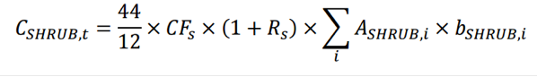
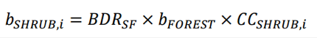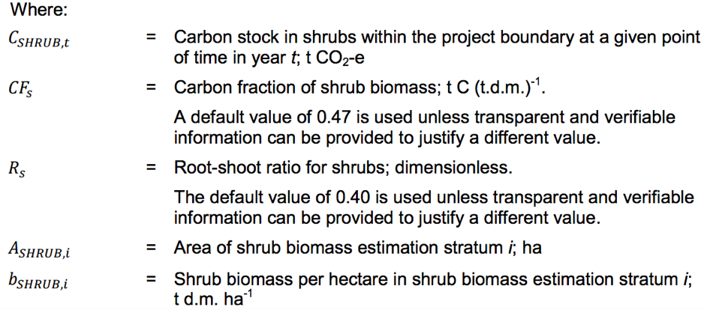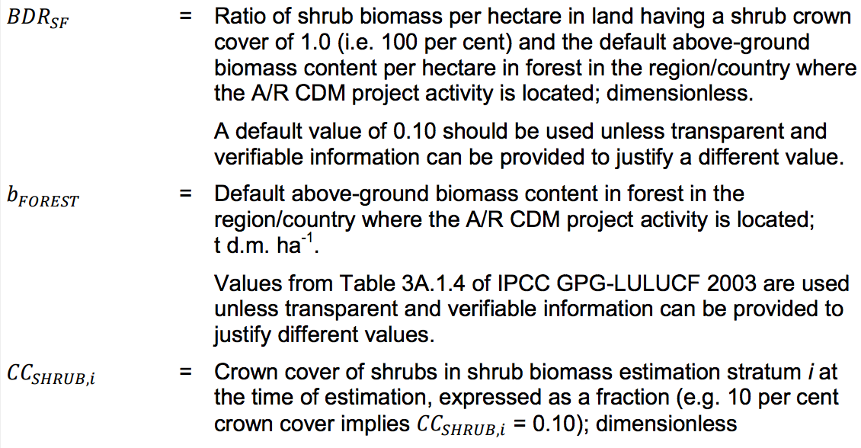
(Courtesy of CDM Methodological tool: Estimation of carbon stocks and change in carbon stocks of trees and shrubs in A/R CDM project activities)

9.3 Optional Carbon Sinks
Optional carbon sinks including soil carbon, deadwood, and litter, may be included or excluded from impacting project quantification. Project monitoring and project contracts maintain these additional pools in line with management practices, so that carbon in optional sinks is stored even if excluded from quantification.
To measure optional sources and sinks of emissions, conservative and appropriate peer-reviewed carbon accumulation methodologies may be proposed, or the established CDM Methodology Tools for: 1) “Estimation of carbon stocks and change in carbon stocks in dead wood and litter in A/R CDM project activities”, and 2) tool for “estimation of change in soil organic carbon stocks due to the implementation of A/R CDM project activities” can provide methodology for optional carbon sink accounting (CDM). Other approved carbon offset program methodologies are also acceptable.

9.4 Fire
Incase fire is used to clear the project site for the afforestation project, or if wildfire damages the Afforestation Project, refer to the CDM Methodology Tool for “Estimation of non-CO₂ GHG emissions resulting from burning of biomass attributable to an A/R CDM project activity”. This tool calculates the impact of non-CO₂ GHG emissions, while CO₂ released can be estimated by resampling and re-stratifying using the guidelines for quantification of forest carbon pools (trees & shrubs) to establish carbon loss from fire.

9.5 Data & Measurement Uncertainty
Data uncertainty is a factor which must be taken into account for all projects. As discussed in the General Protocol, uncertainty can be reduced by direct measurement. This protocol utilizes forest growth estimation models, but supplements these estimations with mandatory proportional sampling every 5-years measuring the accuracy of the estimations. The process of verification provides review for this process, before allowing carbon credits to be allocated to Project Proponents. This process involves physical measurement of project impact, thereby it does not increase overall project uncertainty.
As discussed in the verification section of the protocol, depending on the choice of “Verification Methods” an additional level of uncertainty must be applied to the GHG impact of the project.
The uncertainty amount (e.g. 5%) is subtracted from the total calculated project impact. This new value becomes the updated project impact, and buffer pool contributions will be based on this updated project impact.

10. Project Monitoring
The purpose of monitoring is to ensure the project forest is achieving the goals of generating offsets, sequestering atmospheric CO₂, and providing co-benefits as projected. Monitoring is designed to measure the project activity, ensure compliance with stated management practices, identify leakage, and address potential changes to legal land ownership or rights to the carbon pools.

Monitoring recommendations for all Afforestation projects using this protocol:
- The project start date is the date that the contract governing carbon stored on the project site is signed and active.
- It is recommended that forest areas are mapped with KML or similar files and/or GIS coordinates, denoting biomass stratification information. Photographs should be time-stamped or dated.
  - If planting trees as part of the project, the following data should be collected on all planted trees:
    - Species
    - DBH
    - Height
    - Estimated Age at time of planting
    - GPS Coordinates (optional)
- Each year, including year 1, the carbon stocks must be updated using the projected growth rates for the project’s carbon pools. This estimate should use the latest forest inventory data, and account for any harvesting or disturbance that occurred during the reporting period.
- A “walk-through” survey should occur annually to ensure that Natural Management is being practiced and to check for disturbance events.
  - Disturbance events will be determined on a simple alive/damaged/dead visual check.
  - Prior to performing a walk-through event you must identify potential invasive species that may exist as well as signs to determine if locally prevalent pests or disease could be present in the project area.
- Each monitoring event must also include reviewing the Information Management System account, recording and updating who has access to project files, and removing parties no longer involved with the project’s ongoing activity.
- Beginning in year 5, and continuing every 5th year thereafter, a representative sample survey should occur to verify and adjust the findings of the growth models for verification purposes and to allocate offset credits.
- At the 20th year, the baseline scenario must be recalculated to ensure continued project additionality and accurate project impact. Legal regulations, common practice, and other factors that could influence the project must be considered when reviewing the initial baseline. Crediting is halted, recommencing once the baseline estimate has been updated.

The following timeline is recommended to ensure accounting accuracy and project success for the Afforestation Proponent and Afforestation Site Owner:
Project Timeline | Monitoring Event Type | Data Collected
Start Date – once completed: | Stratification, inventory | Biomass stratification; if trees planted: species, DBH, height, estimated age, (GPS coordinates)
Years 1-4 | “Walk-through” survey | Ensure Management Practice, Identify Disturbance Events
Year 5 | Full inventory | Representative sampling: Species, DBH, height, estimated age, (GPS coordinates)
Years 6-9 | “Walk-through” survey | Ensure Management Practice, Identify Disturbance Events
Year 10 | Full inventory | Representative sampling: Species, DBH, height, estimated age, (GPS coordinates).
Years 11-14 | “Walk-through” survey | Ensure Management Practice, Identify Disturbance Events
Year 15 | Full inventory | Representative sampling: Species, DBH, height, estimated age, (GPS coordinates)
Years 16-19 | “Walk-through” survey | Ensure Management Practice, Identify Disturbance Events
Year 20 | - Full inventory  - Recalculation of baseline scenario | Representative sampling: Species, DBH, height, estimated age, (GPS coordinates). Pertinent laws, common practice and other information to determine baseline suitability.
Years 21-24 | “Walk-through” survey | Ensure Management Practice, Identify Disturbance Events
Year 25 | Full inventory | Representative sampling: Species, DBH, height, estimated age, (GPS coordinates)
Years 26-29 | “Walk-through” survey | Ensure Management Practice, Identify Disturbance Events
Year 30 | Full inventory | Representative sampling: Species, DBH, height, estimated age, (GPS coordinates).
Years 31-34 | “Walk-through” survey | Ensure Management Practice, Identify Disturbance Events
Year 35 | Full inventory | Representative sampling: Species, DBH, height, estimated age, (GPS coordinates)
Years 36-39 | “Walk-through” survey | Ensure Management Practice, Identify Disturbance Events
Year 40 | Full inventory | Representative sampling: Species, DBH, height, estimated age, (GPS coordinates).
…continue cycles | “Walk-through” survey & full inventories | Ensure Management Practice, Identify Disturbance Events. Representative sampling: Species, DBH, height, estimated age, (GPS coordinates).
…40th year after last crediting | Final full inventory | Representative sampling: Species, DBH, height, estimated age, (GPS coordinates).

10.1 Monitoring Report
The monitoring report and the collected data must be made available to verifiers during verification periods. During each monitoring event, the data will be collected and input via computer-based spreadsheet or using software designed for data collection. This spreadsheet or software should be kept up to date and used to estimate carbon offset generation as well as shared for verification purposes. The data collected must be treated with sensitivity, and kept in the cmf@oberlin.edu server with hard copy backup storage, and access restricted in line with Information Management System guidance.

In addition to data collection, a report will be written that includes the following:
- Date(s) of monitoring event/data collection
- Names of data collectors with contact information (both phone number and email address)
- Names and contact info for those granted access to project files within the cmf@oberlin.edu account and access to the backup data storage location
- Type of monitoring event (full inventory, “Walk-through” survey, etc)
- Estimated number of hours spent on monitoring (increments no smaller than 0.5 hours)
- Summary & identification of any trends in the data collected
- Identification of any and all reversals (disturbance events, change to management practices), any and all potential near-future reversals (evidence of tree decline or disease)
- Results from updated carbon stock analysis (if full inventory) with comparison to projected carbon stock. If there is a greater than 5% difference between projected and actual, discuss steps for adjustment (change in buffer pool contribution, locating improved growth models etc).

10.2 Information Management System
Relevant project information must be stored, organized by individual projects, within the cmf@oberlin.edu account google drive. Proprietary or sensitive information of Project Owners, Proponents, Maintainers or project partners must be treated with the utmost care and conscientiousness. Access, via ‘sharing’, to various project files must be documented and annually updated in coordination with the monitoring report. The cmf@oberlin.edu google drive folder automatically tracks activity within the drive providing recourse for information breaches.

Individuals must be removed from access to project files, when their involvement with the project has concluded. Annual monitoring must check access to project files, and coordinate with relevant parties to remove access where appropriate.

11. Verification Requirements
Verification, as detailed in the General Protocol should be referenced to select the appropriate verification category and apply to corresponding uncertainty factor to the project impact. In this section, the verification required for an Afforestation project are outlined while also providing a schedule for verification.

11.1 Verification Requirements
- Project Commencement Verification - A full verification will occur within 2 years of project commencement.
  - During this verification, the verifier(s) are required to do the following:
    - Site visit(s) to ensure existence of project
    - Count planted trees to ensure match with Project Proponents count
    - Verify that all necessary contracts between the Project Proponent and Project Owner(s) are set to ensure that offset ownership is enforceable
    - Review monitoring reports to verify that data collection was properly documented
    - review offset projection spreadsheet for accurate accounting
    - interview data collector(s) about their data collection process
    - Provide required and suggested improvements within the Verification Report
- Desk Verification
  - For years when a “walk-through” internal monitoring survey is completed, the verifier is required to do the following:
    - Review monitoring report for most recent survey
    - If the monitoring report listed any site disturbances or issues with management practices, follow up with the Project Proponent about the plan to address these concerns
- Full Verification
  - After each 5-year monitoring event, the verifier is required to do the following:
    - Site visit(s) to ensure continued existence of project
    - Review project site stratification to ensure it matches the Project Proponent’s
    - Review monitoring reports to verify that data collection was properly documented
    - Interview data collector(s) about their data collection process
    - Interview Project Maintainers about management practices
    - Review offset generation calculations and data input methodology for accurate accounting
    - compare calculated number of generated offsets to projected number of generated offsets to determine if they fall within 5% of each other (if the two numbers are within 5%, then offsets can be disbursed)
    - Ensure all offsets have been given an individual ID and that the appropriate number of offset credits have been placed within the buffer pool.

11.3 Verification Timeline
Time Since Planting | Verification Event
<Year 2 | Project Initiation Verification
Years 2-4 | Desk Verification
Year 5 | Full Verification
Years 6-9 | Desk Verification
Year 10 | Full Verification
Years 11-14 | Desk Verification
Year 15 | Full Verification
Years 16-19 | Desk Verification
Year 20 | Full Verification
Years 21-24 | Desk Verification
Year 25 | Full Verification
Years 26-29 | Desk Verification
Year 30 | Full Verification
Years 31-34 | Desk Verification
Year 35 | Full Verification
Years 36-39 | Desk Verification
Year 40 | Full Verification

12. Appendices

12.1 Protocol Developer’s Background Info
Carbon Management Fund Background
As part of the Climate Leaders Commitment (CLC) including over 700 Colleges and Universities, Oberlin College set a target of achieving carbon neutrality through the Carbon Commitment by 2025. To be carbon neutral, Oberlin will have to offset an estimated 7,000 metric tonnes per year of carbon dioxide or equivalent greenhouse gases in 2025 and subsequent years. The Carbon Management Fund (CMF) was created as a branch of the student led group, the Green EDGE Fund to help Oberlin College reach carbon neutrality. CMF began in 2013, and is developing several carbon offset projects in urban forestry, afforestation, soil management practices, and livestock waste.

Duke Carbon Offset Initiative Background
To meet its goal of climate neutrality by 2024, Duke University will need to offset approximately 185,000 tonnes of carbon dioxide equivalent-emissions per year, starting in 2024, an amount which Duke expects to diminish over time as the University's electricity supplier moves off of coal to renewable sources of energy. Understanding that carbon offsets will play a significant part reaching climate neutrality, the Office of the Executive Vice President established the Duke Carbon Offsets Initiative in June 2009. The Initiative is responsible for developing the University's strategy for meeting its offset goals in a way that provides significant local, state and regional environmental, economic, and societal co-benefits beyond the benefits of greenhouse gas emission reductions.
The DCOI has developed a portfolio approach to generating carbon offsets, focusing on:
- Methane capture projects from North Carolina swine farms through the installation of innovative animal waste management systems. Loyd Ray Farms is the pilot program and current core of DCOI's work;
- Community-based energy efficiency projects, currently being piloted with Duke University students, faculty, and staff; and
- The potential for carbon sequestration through forestry and land conservation-based projects
DCOI also supplies offsets to members of the internal Duke community who wish to offset their individual, departmental or special event emissions where it is not possible to avoid or reduce emissions.
In addition to investigating emerging offset opportunities around the world where there is a clear nexus to the University's activities, DCOI is working to act as a resource for others outside of Duke interested in pursuing offsets projects, thereby serving to facilitate and catalyze high-integrity offset projects.
Mission Statements
Carbon Management Fund: To meet Oberlin College’s carbon neutrality goal by 2025 by developing and implementing local opportunities for impactful carbon offset projects.

Duke Carbon Offset Initiative: To meet its goal of climate neutrality by 2024, and to act as a resource for others outside of Duke interested in pursuing offsets projects, thereby serving to facilitate and catalyze high-integrity offset projects.
Shared Mission:
- To implement carbon reduction strategies in ways that provides educational opportunities and carbon accounting experience for students, and real-world examples to improve curriculum for faculty, and staff;
- To prioritize local, state, and regional offsets that provide significant environmental, economic, and societal co-benefits beyond the benefits of atmospheric GHG reduction; and
- To facilitate and catalyze high-integrity, unique offset projects that will serve as a resource and model for other institutions.

CAR, 2012. Forest Project Protocol Version 3.3. Climate Action Reserve. Climateactionreserve.org. Accessible via: http://www.climateactionreserve.org/how/protocols/forest/dev/version-3-3/
CDM, 2013. AR-AMS0007: Afforestation & Reforestation Project Activities implemented on lands other than wetlands version 3.1. Clean Development Mechanism of the United Nations Council on Climate Change. Cdm.unfccc.int/. https://cdm.unfccc.int/methodologies/DB/J6ZHLX1C3AEMSZ52PWIII6D2AOJZUB
IPCC, 2006. IPCC Guidelines for National Greenhouse Gas Inventories, Chapter 4: Forest Land. IPCC-nggip.iges.or.jp. http://www.ipcc-nggip.iges.or.jp/public/2006gl/pdf/4_Volume4/V4_04_Ch4_Forest_Land.pdf
American Carbon Registry, 2009. The American Carbon Registry Forest Carbon Project Standard Version 1. www.responsiblepurchasing.org. http://www.responsiblepurchasing.org/purchasing_guides/carbon_offsets/standards/American_Carbon_Registry_Forest_Carbon_Project_Standard.pdf
CAR, 2012. Forest Project Protocol Version 3.3. Climate Action Reserve. Climateactionreserve.org. Accessible via: http://www.climateactionreserve.org/how/protocols/forest/dev/version-3-3/
CAR, 2012. Forest Project Protocol Version 3.3. Climate Action Reserve. Climateactionreserve.org. Accessible via: http://www.climateactionreserve.org/how/protocols/forest/dev/version-3-3/
ODPS Ohio Emergency Management Agency, 2014. State of Ohio Hazard Mitigation Plan: Section 2.7. www.ohio.gov. http://ema.ohio.gov/Documents/OhioMitigationPlan/SOHMP_Sec_2_7.pdf
CDM, 2015. Estimation of carbon stocks and change in carbon stocks in trees and shrubs in A/R CDM project activities version 4.2. Clean Development Mechanism of the United Nations Framework Convention on Climate Change http://cdm.unfccc.int/methodologies/ARmethodologies/tools/ar-am-tool-14-v4.2.pdf

